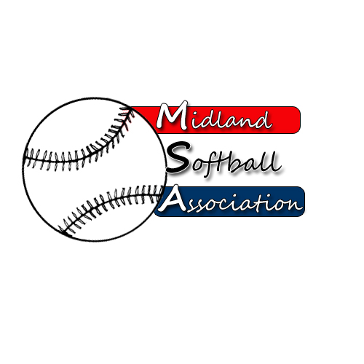

MSA Board Meeting
Monday, October 12, 2015
5:30 pm – Parks and recreation

- Call to order
- Public Comment
- Minutes from: July 13, 2015
- Treasurer’s Report
- UIC Update
- New Business
  - Early Bird Discount
  - Tournament in the Schedule (less forfeits)
  - Survey
  - Grand Masters Meeting Summary
  - Meeting dates 2016
- Old Business
  - Strategic Plan
- Additional Public Comments
- Next Meeting Date
- Adjourn

