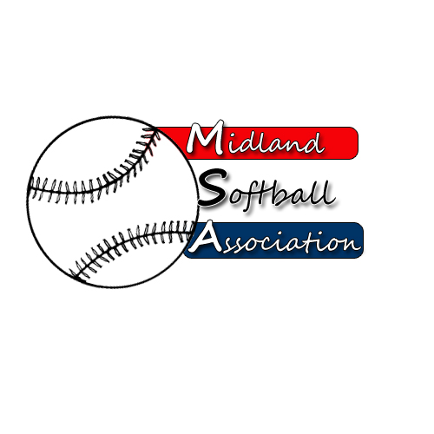

MSA Board Meeting
Monday, November 10, 2014
5:30 pm – Parks and recreation

- Call to order
- Minutes from:
- Treasurer’s Report
- Public Comment
- UIC Update
- Old Business
- New Business
  - 2014 Team Report
  - Fees for 2015, 2016
  - League Tournament 2015
  - Advertising
  - Survey Questions
  - Redcoats Improvements (Pavilion, Picnic Tables, Benches, Field 12 Backstop, Warning tracks, Remote Lighting, Bathroom Sensors, etc.)

  - Managers Letter 2015 (Dates, Annual Meeting, Season Start, etc.)
- Additional Public Comments
- Next Meeting Date
- Adjourn

