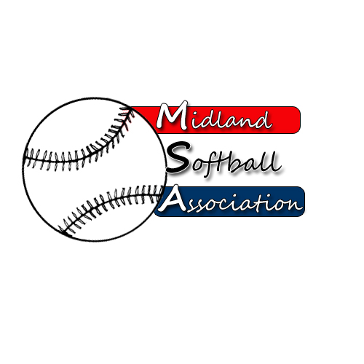

MSA Board Meeting
Monday, APRIL 10, 2017
5:30 pm – pARKS AND rECREATION

- Call to Order
- Public Comment
- Minutes from March 2017
- Treasurer’s Report
- UIC Update
- Protest Committee Update
- New Business
  - Bylaw Changes
- Old Business
- Additional Public Comments
- Next Meeting Date
- Adjourn

