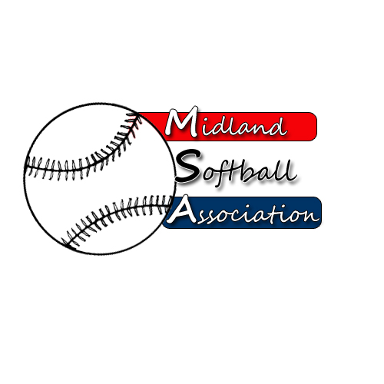

MSA Board Meeting
Monday, April 9, 2018
5:30 pm – pARKS AND rECREATION

- Call to order
- Public Comment
- Minutes from: March 12, 2018
- Treasurer’s Report
- UIC Update
- Protest Committee Update
- New Business
  - Appeals – Jordon Wise & Charlie London
  - By-law suggestions
  - Annual Meeting plan - Elections
  - Field Material – MSA pay for material
- Old Business
- Strategic Planning –
- Bat Testing -
- Redcoats Light bulbs – Lightbulbs have started to be installed (Lower Towers)
(Upper Towers) Starting next week
- Additional Public Comments
- Next Meeting Date: Annual Meeting April 12, 7:00pm
- Adjourn

