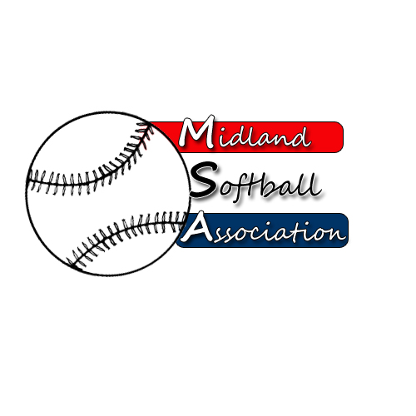

MSA Board Meeting
Monday, April 13, 2015
5:30 pm – Parks and recreation

- Call to order
- Public Comment
  - Fred Blackhurst
  - Noah Ponte
- Minutes from: March 9, 2015
- Treasurer’s Report
- UIC Update
- New Business
  - Grand Master's Rules Approval
  - Bat Testing Dates
  - Fall Coed
- Old Business
  - Bylaw Changes
  - Advertising proposal
  - Strategic Plan
- Additional Public Comments
- Next Meeting Date
- Adjourn

