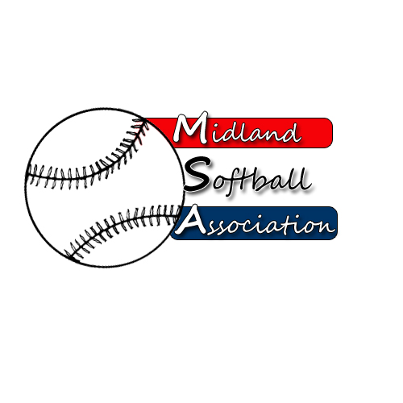

MSA Board Meeting
Monday, december 12, 2016
5:30 pm – pARKS AND rECREATION

- Call to order
- Public Comment
- Minutes from: __________
- Treasurer’s Report
- UIC Update
- Protest Committee Update
- New Business
- Old Business
  - Annual Meeting Date
  - Bob’s Protest
- Additional Public Comments
- Next Meeting Date – JANUARY
- Adjourn

