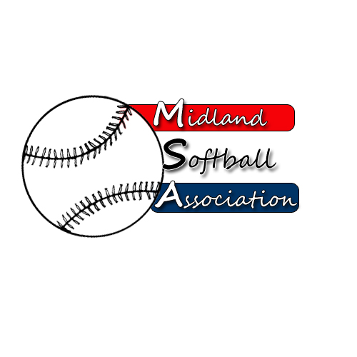

MSA Board Meeting
Monday, March 12, 2018
5:30 pm – pARKS AND rECREATION

- Call to order
- Public Comment
- Minutes from: January 8, 2018
- Treasurer’s Report
- UIC Update
- Protest Committee Update
- New Business
  - Bylaw committee –
  - Arbiterpay – Umpires pay biweekly/fees
  - Annual Meeting plan
  - Field Material – MSA pay for material
  - Meeting survey – Meetings will stay on Mondays
- Old Business
- Strategic Planning –
- Redcoats Light bulbs – Lightbulbs are sitting in storage until city starts install
- Additional Public Comments
- Next Meeting Date
- Adjourn

