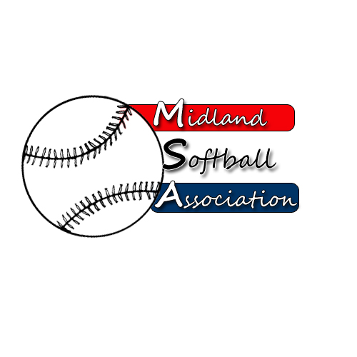

MSA Board Meeting
Monday, May 14, 2018
5:30 pm – pARKS AND rECREATION

- Call to order
- Public Comment
- Minutes from: April 9, 2018
- Treasurer’s Report
- UIC Update
- Protest Committee Update
- New Business
  - Welcome new board members
  - Team Refund – WannaB’s MSP $200
  - Bat Test Stickers for Dow League
- Old Business
- Additional Public Comments
- Next Meeting Date: Annual Meeting April 11, 7:00pm
- Adjourn

