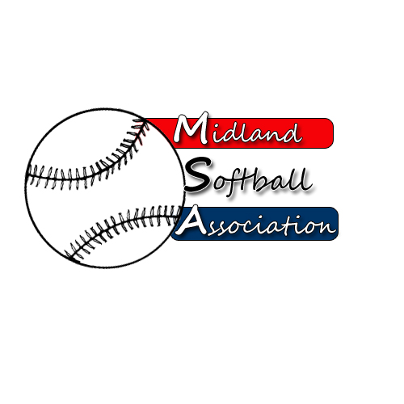

MSA Board Meeting
Monday, June 8, 2015
5:30 pm – Parks and recreation

- Call to order
- Public Comment
- Minutes from: April 13, 2015
- Treasurer’s Report
- UIC Update
- New Business
  - Refunds
  - Protest - Men's Grand Masters Net Rule
  - Men's Modified Shorthanded Rule
  - Umpire Shortage
- Old Business
  - Strategic Plan
- Additional Public Comments
- Next Meeting Date
- Adjourn

