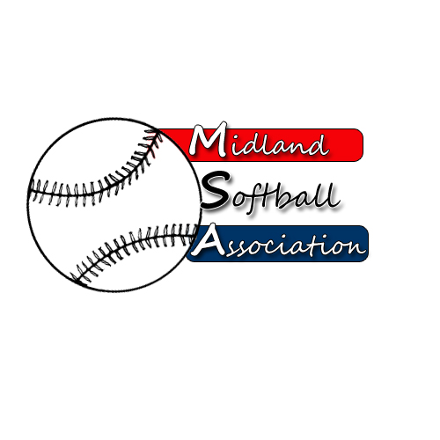

MSA Board Meeting
Monday, April 8, 2013
5:30 pm – Parks and Recreation

- Call to order
- Minutes from: March 10, 2014
- Treasurer’s Report
- Public Comment
- UIC Update
- Old Business
- New Business
  - Bylaw Review for Annual Meeting
  - Agenda for Annual Meeting
  - Approval of Slate
  - 2015 MASA Tournament Bids
- Next Meeting Date
- Public Comment
- Adjourn

