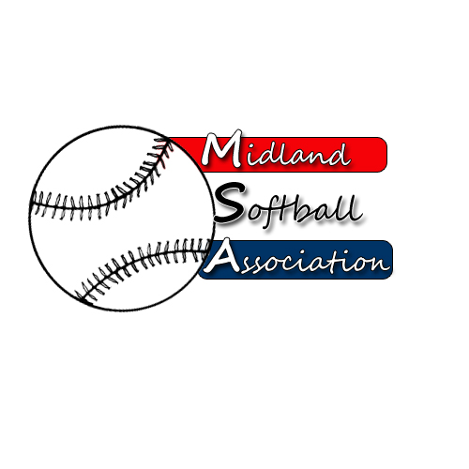

MSA Board Meeting
Monday, January 12, 2015
5:30 pm – Parks and recreation

- Call to order
- New Business
  - Fee Discussion with Parks and Recreation Administrative Staff
  - Bylaw Changes
- Minutes from: December 8, 2014
- Treasurer’s Report
- UIC Update
- Old Business
- 2014 League Survey
- Advertising proposal
- Strategic Plan
- Additional Public Comments
- Next Meeting Date
- Adjourn

Meeting Notes

Fee Discussion with P&R Administrative Staff: Karen Murphy will be in attendance at this month's meeting to discuss the relationship between the MSA and the Parks and Recreation Department. This item has been moved to the

Bylaw Changes: Any possible changes to the bylaws. Please come prepared with any potential changes.

2014 League Survey: In the body of the email you will find a link to the Survey Monkey Results. The results can also be found by viewing the link here: https://www.surveymonkey.com/results/SM-V98THBFV/.

Advertising proposal: We sent you the draft proposal last month as well. Bring comments with you.

